Университет ИТМО

Мегафакультет компьютерных технологий и управления

Факультет программной инженерии и компьютерной техники



Лабораторная работа по программированию №2

Вариант №21529

Группа: P3115

Студент: Сущенко Роман Витальевич

Преподаватель: Усков Иван Владимирович

г. Санкт-Петербург

Сентябрь, 2021

Задание:

На основе базового класса Pokemon написать свои классы для заданных видов покемонов. Каждый вид покемона должен иметь один или два типа и стандартные базовые характеристики:

* очки здоровья (HP)
* атака (attack)
* защита (defense)
* специальная атака (special attack)
* специальная защита (special defense)
* скорость (speed)

Классы покемонов должны наследоваться в соответствии с цепочкой эволюции покемонов. На основе базовых классов PhysicalMove, SpecialMove и StatusMove реализовать свои классы для заданных видов атак.

Атака должна иметь стандартные тип, силу (power) и точность (accuracy). Должны быть реализованы стандартные эффекты атаки. Назначить каждому виду покемонов атаки в соответствии с вариантом. Уровень покемона выбирается минимально необходимым для всех реализованных атак.

Используя класс симуляции боя Battle, создать 2 команды покемонов (каждый покемон должен иметь имя) и запустить бой.

Диаграмма классов реализованной объектной модели:

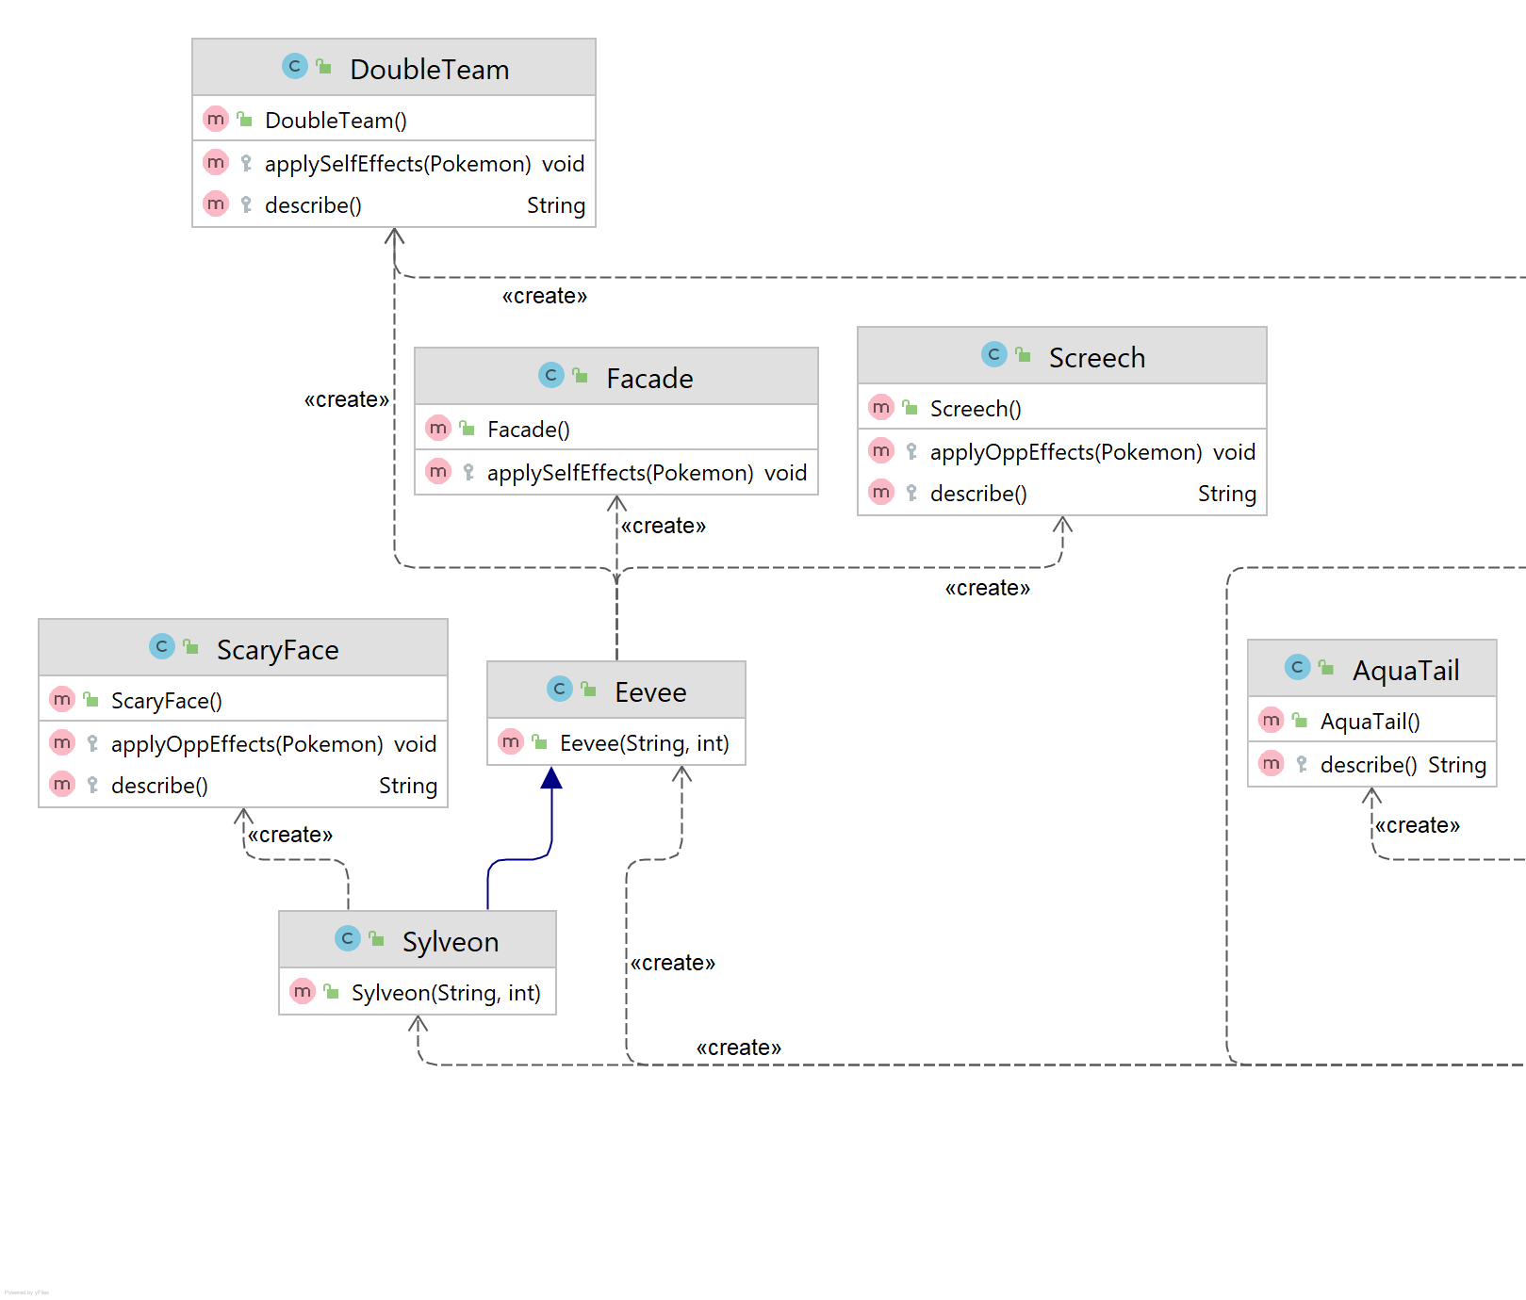

Исходный код: <https://github.com/catboop/itmo_programming/tree/main/lab2/src>

Результат работы программы:

Kyurem Kyurem from the team Red enters the battle!

Spheal Spheal from the team Black enters the battle!

Kyurem Kyurem using Aqua Tail.

Spheal Spheal loses 6 hit points.

Spheal Spheal misses

Kyurem Kyurem misses

Spheal Spheal misses

Kyurem Kyurem using Aqua Tail.

Spheal Spheal loses 7 hit points.

Spheal Spheal faints.

Sealeo Sealeo from the team Black enters the battle!

Kyurem Kyurem using Aqua Tail.

Sealeo Sealeo loses 6 hit points.

Sealeo Sealeo misses

Kyurem Kyurem using Crunch.

Sealeo Sealeo loses 12 hit points.

Sealeo Sealeo faints.

Walrein Walrein from the team Black enters the battle!

Kyurem Kyurem misses

Walrein Walrein misses

Kyurem Kyurem misses

Walrein Walrein using Will-O-Wisp.

Kyurem Kyurem is burned

Kyurem Kyurem loses 1 hit points.

Kyurem Kyurem misses

Walrein Walrein using Will-O-Wisp.

Kyurem Kyurem loses 1 hit points.

Kyurem Kyurem using Aqua Tail.

Walrein Walrein restores 1 hit points.

Walrein Walrein misses

Kyurem Kyurem loses 1 hit points.

Kyurem Kyurem using Crunch.

Walrein Walrein restores 1 hit points.

Walrein Walrein misses

Kyurem Kyurem loses 1 hit points.

Kyurem Kyurem using Crunch.

Walrein Walrein restores 1 hit points.

Walrein Walrein misses

Kyurem Kyurem loses 1 hit points.

Kyurem Kyurem misses

Walrein Walrein using Will-O-Wisp.

Kyurem Kyurem loses 1 hit points.

Kyurem Kyurem misses

Walrein Walrein misses

Kyurem Kyurem loses 1 hit points.

Kyurem Kyurem using Aqua Tail.

Walrein Walrein restores 1 hit points.

Walrein Walrein misses

Kyurem Kyurem loses 1 hit points.

Kyurem Kyurem using Aqua Tail.

Walrein Walrein restores 1 hit points.

Walrein Walrein using Will-O-Wisp.

Kyurem Kyurem loses 1 hit points.

Kyurem Kyurem misses

Walrein Walrein misses

Kyurem Kyurem loses 1 hit points.

Kyurem Kyurem using Aqua Tail.

Walrein Walrein restores 1 hit points.

Walrein Walrein misses

Kyurem Kyurem loses 1 hit points.

Kyurem Kyurem using Crunch.

Walrein Walrein restores 1 hit points.

Walrein Walrein using Will-O-Wisp.

Kyurem Kyurem loses 1 hit points.

Kyurem Kyurem misses

Walrein Walrein using Will-O-Wisp.

Kyurem Kyurem loses 1 hit points.

Kyurem Kyurem using Aqua Tail.

Walrein Walrein restores 1 hit points.

Walrein Walrein misses

Kyurem Kyurem loses 1 hit points.

Kyurem Kyurem misses

Walrein Walrein misses

Kyurem Kyurem loses 1 hit points.

Kyurem Kyurem misses

Walrein Walrein using Will-O-Wisp.

Kyurem Kyurem loses 1 hit points.

Kyurem Kyurem using Aqua Tail.

Walrein Walrein restores 1 hit points.

Walrein Walrein misses

Kyurem Kyurem loses 1 hit points.

Kyurem Kyurem misses

Walrein Walrein misses

Kyurem Kyurem loses 1 hit points.

Kyurem Kyurem using Crunch.

Walrein Walrein restores 1 hit points.

Walrein Walrein misses

Kyurem Kyurem loses 1 hit points.

Kyurem Kyurem using Crunch.

Walrein Walrein restores 1 hit points.

Walrein Walrein misses

Kyurem Kyurem loses 1 hit points.

Kyurem Kyurem using Crunch.

Walrein Walrein misses

Kyurem Kyurem loses 1 hit points.

Kyurem Kyurem using Crunch.

Walrein Walrein misses

Kyurem Kyurem loses 1 hit points.

Kyurem Kyurem misses

Walrein Walrein using Will-O-Wisp.

Kyurem Kyurem loses 1 hit points.

Kyurem Kyurem using Aqua Tail.

Walrein Walrein restores 1 hit points.

Walrein Walrein misses

Kyurem Kyurem loses 1 hit points.

Kyurem Kyurem misses

Walrein Walrein using Will-O-Wisp.

Kyurem Kyurem loses 1 hit points.

Kyurem Kyurem misses

Walrein Walrein misses

Kyurem Kyurem loses 1 hit points.

Kyurem Kyurem misses

Walrein Walrein misses

Kyurem Kyurem loses 1 hit points.

Kyurem Kyurem misses

Walrein Walrein misses

Kyurem Kyurem loses 1 hit points.

Kyurem Kyurem using Crunch.

Walrein Walrein misses

Kyurem Kyurem loses 1 hit points.

Eevee Eevee from the team Red enters the battle!

Walrein Walrein using Will-O-Wisp.

Eevee Eevee is burned

Eevee Eevee misses

Eevee Eevee loses 1 hit points.

Walrein Walrein misses

Eevee Eevee misses

Eevee Eevee loses 1 hit points.

Walrein Walrein misses

Eevee Eevee attacks.

Eevee Eevee loses 1 hit points.

Walrein Walrein misses

Eevee Eevee attacks.

Walrein Walrein restores 1 hit points.

Eevee Eevee loses 1 hit points.

Walrein Walrein misses

Eevee Eevee attacks.

Walrein Walrein restores 1 hit points.

Eevee Eevee loses 1 hit points.

Walrein Walrein misses

Eevee Eevee misses

Eevee Eevee loses 1 hit points.

Walrein Walrein misses

Eevee Eevee misses

Eevee Eevee loses 1 hit points.

Walrein Walrein misses

Eevee Eevee misses

Eevee Eevee loses 1 hit points.

Walrein Walrein misses

Eevee Eevee misses

Eevee Eevee loses 1 hit points.

Walrein Walrein misses

Eevee Eevee attacks.

Eevee Eevee loses 1 hit points.

Walrein Walrein misses

Eevee Eevee attacks.

Eevee Eevee loses 1 hit points.

Walrein Walrein misses

Eevee Eevee attacks.

Walrein Walrein restores 1 hit points.

Eevee Eevee loses 1 hit points.

Walrein Walrein using Will-O-Wisp.

Eevee Eevee attacks.

Walrein Walrein restores 1 hit points.

Eevee Eevee loses 1 hit points.

Walrein Walrein misses

Eevee Eevee misses

Eevee Eevee loses 1 hit points.

Walrein Walrein misses

Eevee Eevee misses

Eevee Eevee loses 1 hit points.

Walrein Walrein misses

Eevee Eevee misses

Eevee Eevee loses 1 hit points.

Walrein Walrein misses

Eevee Eevee misses

Eevee Eevee loses 1 hit points.

Sylveon Sylveon from the team Red enters the battle!

Walrein Walrein misses

Sylveon Sylveon misses

Walrein Walrein misses

Sylveon Sylveon misses

Walrein Walrein misses

Sylveon Sylveon attacks.

Walrein Walrein misses

Sylveon Sylveon misses

Walrein Walrein misses

Sylveon Sylveon attacks.

Walrein Walrein loses 3 hit points.

Walrein Walrein misses

Sylveon Sylveon misses

Walrein Walrein misses

Sylveon Sylveon misses

Walrein Walrein misses

Sylveon Sylveon attacks.

Walrein Walrein loses 5 hit points.

Walrein Walrein misses

Sylveon Sylveon attacks.

Walrein Walrein loses 391 hit points.

Walrein Walrein faints.

Team Black loses its last Pokemon.

The team Red wins the battle!

Process finished with exit code 0

Вывод:

Разобрался с основными концепциями объектно-ориентированного программирования и научился использовать их в программе, также научился подключать сторонние библиотеки к программе.